
VASIREDDY VENKATADRI INSTITUTE OF TECHNOLOGY
Approved by AICTE, Permanently Affiliated to JNTU, Kakinada
Accredited by NAAC with ‘A’ Grade - ISO 9001:2008 Certified
Nambur (V), Peda Kakani (M), Guntur Dt. - 522508 April, 2025.

A Project Report
On

EcoShare – Smart Food & Clothes Donation System

submitted for partial fulfillment for the award of the degree of

BACHELOR OF TECHNOLOGY
in

Computer Science and Engineering
By

Pundla Venkatalakshmi Satyasri – 23BQ1A05I8 NEELAM MOHANA RUPA –23BQ1A05F7
Janga Prem Chand – 23BQ1A05I3
Namburu Gagan Sai –23BQ1A05F6

Under the Guidance of
Dr.Nallamalla Sri Hari
Professor, CSE



CERTIFICATE

This is to certify that the Project Report titled “EcoShare – Smart Food & Clothes Donation System” is being submitted by, Ms. Pundla Venkatalakshmi Satyasri,
Ms. NEELAM MOHANA RUPA, Mr. Janga Prem Chand, Mr. Namburu Gagan Sai, bearing Registered Numbers 23BQ1A05I8, 23BQ1A05F7, 23BQ1A05I3, and 23BQ1A05F6
respectively of III B.Tech II semester Computer Science & Engineering is a record Bonafide work carried out by them. The results embodied in this report have not been submitted to any other University for the award of any degree.

Project Guide Head of Department
(Dr.Nallamalla Sri Hari, Professor) (Dr. V. Ramachandran, Professor)

Submitted for Viva-voce Examination held on

Internal Examiner External Examiner

DECLARATION

We, Ms. Pundla Venkatalakshmi Satyasri, Ms. Neelam Mohana Rupa, Mr. Janga Prem Chand, Mr. Namburu Gagan Sai, hereby declare that the Project Report entitled “EcoShare – Smart Food & Clothes Donation System” done by us under the guidance of Dr. Nallamalla Sri Hari, Professor at Vasireddy Venkatadri Institute of Technology (A), is submitted in partial fulfillment of the requirements for the award of Bachelor of Technology in Computer Science & Engineering. The results embodied in this report have not been submitted to any other university for the award of any degree.

DATE :

PLACE :

SIGNATURE OF THE CANDIDATE(s)

1.

2.

3.

4.

ACKNOWLEDGEMENT

We take this opportunity to express my deepest gratitude and appreciation to all those people who made this project work easier with words of encouragement, motivation, discipline, and faith by offering different places to look to expand our ideas and helped us towards the successful completion of this project work.
First and foremost, we express our deep gratitude to Sri. Vasireddy Vidya Sagar, Chairman, Vasireddy Venkatadri Institute of Technology (A) for providing necessary facilities throughout the B Tech program.
We express our sincere thanks to Dr. Y. Mallikarjuna Reddy, Principal, Vasireddy Venkatadri Institute of Technology (A) for his constant support and cooperation throughout the
B. Tech program.
We express our sincere gratitude to Dr. V. Ramachandran, Professor & HOD, Computer Science & Engineering, Vasireddy Venkatadri Institute of Technology (A) for his constant encouragement, motivation and faith in offering different places to look to expand our ideas.
We would like to express our sincere gratefulness to our Guide Dr. Nallamalla Sri Hari, Associate Professor, CSE for his insightful advice, motivating suggestions, invaluable guidance, help and support in the successful completion of this project.
We would like to express our sincere heartfelt thanks to our Project Coordinator Dr. Vidya Sagar Uppuluri, Professor, CSE for his valuable advices, motivating suggestions, moral support, help and coordination among us in successful completion of this project.
We would like to take this opportunity to express our thanks to all the Teaching and Non-Teaching Staff in the Department of Computer Science & Engineering, VVIT for their invaluable help and support.

Name (s) of Students

Pundla Venkatalakshmi Satyasri – 23BQ1A05I8

NEELAM MOHANA RUPA –23BQ1A05F7
Janga Prem Chand – 23BQ1A05I3
Namburu Gagan Sai –23BQ1A05F6



INSTITUTE VISSION

To impart quality education through exploration and experimentation and generate socially conscious engineers, embedding ethics and values, for the advancement in Science and Technology.

INSTITUTE MISSION

- To educate students with practical approach to dovetail them to industry needs.
- To govern the institution with a proactive and professional management with passionate teaching faculty.
- To provide holistic and integrated education and achieve over all development of students imparting scientific and technical, social and cognitive, managerial and organizational skills.
- To compete with the best and be the most preferred institution of the studious and the scholarly.
- To forge strong relationships and linkage with the industry.



DEPARTMENT VISSION

Providing quality education to enable the generation of socially conscious software engineers who can contribute to the advancement in the field of computer science and engineering.

DEPARTMENT MISSION

- To equip the graduates with the knowledge and skills required to enable them to be industry ready.

- To train socially responsible, disciplined engineers who work with good leadership skills and can contribute for nation building.

- To make our graduates proficient in cutting edge technologies through student centric teaching- learning process and empower them to contribute significantly to the software industry.

- To shape the department into a centre of academic and research excellence.





PEO1 | To provide the graduates with solid foundation in computer science and engineering along with fundamentals of Mathematics and Sciences with a view to impart in them high quality technical skills like modelling, analyzing, designing, programming and implementation with global competence and helps the graduates for life-long learning.
PEO2 | To prepare and motivate graduates with recent technological developments related to core subjects like programming, databases, design of compilers and Network Security aspects and future technologies so as to contribute effectively for Research & Development by participating in professional activities like publishing and seeking copy rights.
PEO3 | To train graduates to choose a decent career option either in high degree of employability / Entrepreneur or, in higher education by empowering students with ethical administrative acumen, ability to handle critical situations and training to excel in competitive examinations.
PEO4 | To train the graduates to have basic interpersonal skills and sense of social responsibility that paves them a way to become good team members and leaders.



The B.Tech CSE programme has documented measurable outcomes that are based on the needs of the programme’s stakeholders. The programme outcomes, which are derived from ABET criteria, were first drafted in the academic year 2009–10 and later revised in 2010–11. The programme outcomes that the department presently adopts are as follows:

1 | Engineering knowledge | Apply the knowledge of mathematics, science, engineering fundamentals and an engineering specialization to the solution of complex engineering problems.
2 | Problem analysis | Identify, formulate, review research literature, and analyze complex engineering problems reaching substantiated conclusions using first principles of mathematics, natural science and engineering sciences.
3 | Design/development of solutions | Design solutions for complex engineering problems and design system components or processes that meet the specified needs with appropriate consideration for the public health and safety, and the cultural, societal and environmental considerations.
4 | Conduct investigations of complex problems | Use research based knowledge and research methods including design of experiments, analysis and interpretation of data, and synthesis of the information to provide valid conclusions.
5 | Modern tool usage | Create, select and apply appropriate techniques, resources and modern engineering and IT tools including prediction and modeling to complex engineering activities with an understanding of the limitations.



6 | The Engineer and Society | Apply reasoning informed by the contextual knowledge to assess societal, health, safety, legal and cultural issues and the consequent responsibilities relevant to the professional engineering practice.
7 | Environment and Sustainability | Understand the impact of the professional engineering solutions in the societal and environmental contexts, and demonstrate the knowledge of, and need for sustainable development.
8 | Ethics | Apply ethical principles and commit to professional ethics and responsibilities and norms of the engineering practice.
9 | Individual and Team Work | Function effectively as an individual and as a member or leader in diverse teams, and in multidisciplinary settings.
10 | Communication | Communicate effectively on complex engineering activities with the engineering community and with society at large, such as being able to comprehend and write effective reports and design documentation, make effective presentations, and give and receive clear instructions.
11 | Project Management and Finance | Demonstrate knowledge and understanding of the engineering and management principles and apply these to one’s own work, as a member and leader in a team, to manage projects and in multidisciplinary environments.
12 | Lifelong Learning | Recognize the need for, and have the preparation and ability to engage in independent and lifelong learning in the broadest context of technological change.



 |  | 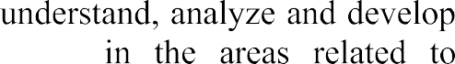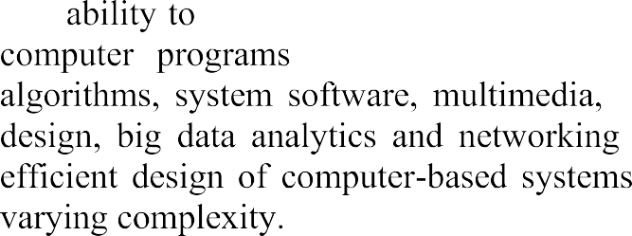
 |  | 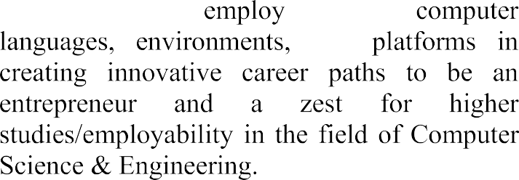







 | PO1 | PO2 | PO3 | PO4 | PO5 | PO6 | PO7 | PO8 | PO9 | PO10 | PO11 | PO12 | PSO1 | PSO2
CO1 | 1 | 2 | 1 |  |  | 2 | 2 | 3 |  | 2 |  |  | 1
CO2 | 2 | 2 | 3 | 2 | 2 |  | 2 | 1 | 2 | 2 | 2 | 1 | 3 | 1
CO3 |  | 1 | 1 | 1 | 3 |  |  |  |  |  |  | 1 | 1
CO4 | 1 |  |  |  |  |  |  |  | 3 | 3 |  |  | 1 | 1
CO5 |  | 1 |  |  |  |  |  | 2 | 3 | 3 | 2 |  | 1 | 2

INDEX

CH No | TITLE | PAGE NO
CHAPTER 1 | INTRODUCTION | 1–2
 | 1.1 Introduction
CHAPTER 2 | AIM AND SCOPE | 3-8
 | 2.1 Existing System
 | 2.2 Proposed System
CHAPTER 3 | CONCEPT AND METHODS | 9-13
 | 3.1 Problem Description
 | 3.2 Proposed Solution
 | 3.2.1 Database Design
 | 3.2.2 Data Collection
 | 3.2.3 Data Validation and Processing
 | 3.2.4 Data Enrichment
 | 3.2.5 System Architecture
 | 3.2.6 System Evaluation Metrics
CHAPTER 4 | IMPLEMENTATION | 14-25
 | 4.1 Tools Used
 | 4.2 Code
 | 4.3 Results and Screenshots
CHAPTER 5 | CONCLUSION AND FUTURE SCOPE | 26-29
 | CONCLUSION
 | FUTURE SCOPE
 | REFERENCES
 | APPENDIX

ABSTRACT

Food and clothing wastage, along with unequal resource distribution, are among the major challenges faced in today’s society. Large quantities of surplus food from households, restaurants, and hostels, as well as usable clothes, are often discarded, while many people continue to lack access to basic necessities. Traditional donation systems rely on manual coordination between donors and NGOs, which is time-consuming, unorganized, and inefficient. Modern web-based systems provide an effective solution to improve coordination, reduce wastage, and ensure better resource utilization.
In this study, we propose EcoShare, a smart platform for managing food and clothes donations. The system connects donors, NGOs, and compost centers through a centralized web application. Donors can create donations by providing details such as type, quantity, and location. NGOs can view and accept available donations, manage collection, and distribute resources to people in need. For food donations that are not collected within a specified time, the system redirects them to compost centers for eco-friendly disposal, ensuring sustainable waste management.
The project is developed using modern web technologies, with React used for building an interactive user interface and Firebase used for authentication and database management to ensure secure storage and real-time updates of donation data. The system is deployed online, allowing users to create donations, accept requests, and track donation status through role-based dashboards.
By leveraging web technologies and structured workflows, the EcoShare system provides a reliable and automated solution for managing donations. It reduces manual effort, improves coordination between stakeholders, and ensures proper utilization of resources. The system contributes to reducing food and clothing wastage while supporting underprivileged communities and promoting environmental sustainability.

CHAPTER - 1

INTRODUCTION

Food and clothing wastage are among the major challenges faced by society today. Large quantities of surplus food from homes, hostels, restaurants, and events are discarded daily, while many people struggle with hunger and lack of access to basic necessities. Similarly, usable clothes are often thrown away instead of being reused or donated to those in need. If these resources are not properly managed, they contribute to environmental pollution and social inequality. Efficient collection, distribution, and monitoring of donations are essential to address these issues. Traditionally, donation systems rely on manual coordination between donors and charitable organizations, which can be inefficient, time-consuming, and unorganized. This often results in delayed responses, wastage of resources, and lack of transparency in the donation process. To overcome these challenges, our project EcoShare – Smart Food & Clothes Donation System leverages modern web technologies to create an automated and efficient donation management platform.
The system follows a structured workflow to ensure efficient handling of donations. In the first phase, donors can upload details of surplus food and clothes through a user-friendly interface. The system automatically assigns the donation to nearby NGOs based on availability and location. This automated assignment reduces manual effort and ensures faster response times. Real-time tracking features allow donors to monitor the status of their donations, providing transparency and reliability in the system. By focusing on efficient matching between donors and NGOs, the system improves the overall effectiveness of the donation process.
In the second phase, once a donation is accepted, NGOs manage the collection and distribution process. Food donations are prioritized for immediate delivery to ensure freshness and usability. If food items are not collected within the specified time and become expired, the system redirects them to compost centers for eco-friendly waste management. Clothes donations, on the other hand, are collected and distributed to underprivileged individuals through NGOs, ensuring maximum utilization of resources. This dual-handling approach for food and clothes ensures both social impact and environmental sustainability.

The entire system is implemented using modern web development technologies such as React for the frontend, Firebase Authentication for secure user management, and Firestore Database for real-time data storage and updates. The application is designed with role-based dashboards for Donors, NGOs, and Admin, providing a seamless and user-friendly experience. Notifications and status updates are integrated into the system to keep users informed at every stage of the donation lifecycle. The platform is deployed online, enabling users to access it anytime and from anywhere.
By integrating automation and sustainable waste management practices, EcoShare provides a reliable, scalable, and impactful solution for managing food and clothes donations. It not only reduces wastage and supports people in need but also promotes environmental sustainability through composting of expired food. This project represents a meaningful step toward building a smarter and more responsible society by effectively utilizing technology to address real-world challenges.

CHAPTER – 2

AIM AND SCOPE

The project “EcoShare – Smart Food & Clothes Donation System” aims to develop an efficient and automated platform for managing the donation and distribution of surplus food and clothes. In today’s world, a significant amount of food and usable clothing is wasted due to the lack of proper coordination between donors and charitable organizations. At the same time, many individuals struggle to access basic necessities. Traditional donation methods rely on manual communication, which is often unorganized, time-consuming, and inefficient. This project aims to overcome these challenges by utilizing modern web technologies to provide a structured, reliable, and user-friendly donation system.
The primary goal of this project is to design a centralized system that connects donors, NGOs, and administrators to ensure efficient resource utilization. The system allows donors to contribute surplus food and clothes through an easy-to-use interface. Once a donation is created, it is assigned to NGOs who are responsible for collecting and distributing the items to those in need. This approach minimizes delays and ensures that donations are handled effectively.
The system follows a structured workflow for handling different types of donations. For food donations, priority is given to timely collection and distribution to prevent wastage. If food items are not collected within a specific time and become unsuitable for consumption, the system redirects them to compost centers for eco-friendly disposal. For clothes donations, the collected items are distributed to underprivileged individuals through NGOs, ensuring maximum utilization of resources. This dual approach ensures both social impact and environmental sustainability.
To make the system accessible and easy to use, a web-based application is developed using modern technologies such as React for the frontend and Firebase for backend services, including authentication and database management. The platform provides role-based dashboards for Donors, NGOs, and Admin, allowing each user to interact with the system according to their responsibilities. Donation details, status updates, and user information are securely stored in a database, ensuring proper record maintenance and easy retrieval.
The EcoShare system is especially useful in areas where organized donation management is lacking. It provides a scalable and cost-effective solution that reduces food and clothing wastage while supporting people in need. By improving coordination between donors and NGOs, the system ensures better resource distribution and minimizes inefficiencies in the donation process.
By enhancing donation management and promoting sustainable practices, this project contributes to reducing waste and supporting community welfare. The system can be further expanded in the future by integrating advanced features such as mobile applications, intelligent donation matching, and improved tracking mechanisms. Overall, EcoShare represents a practical and impactful solution that uses technology to address real-world problems related to resource wastage and social support.

EXISTING SYSTEMS
Food and clothes donation systems have traditionally relied on manual coordination between donors and charitable organizations such as NGOs and volunteers. These conventional methods, although helpful to some extent, suffer from several limitations including lack of organization, inefficient communication, and absence of proper tracking mechanisms. The dependence on manual processes makes the system slow, unreliable, and difficult to scale, especially in areas with high demand for donations. To address these challenges, various approaches have been explored, ranging from traditional donation practices to basic digital platforms.
1. Manual and Traditional Donation Systems
Traditionally, donation activities are carried out through direct communication between donors and NGOs or through physical visits to donation centers. Donors inform NGOs about available food or clothes, and NGOs arrange collection based on availability.
This approach has several drawbacks:
- Lack of Coordination: No structured system to connect donors and NGOs efficiently
- Time-Consuming: Communication delays can lead to food spoilage
- Limited Reach: Donations are restricted to nearby areas only
- No Proper Tracking: Donors cannot monitor the status of their donations
- Resource Wastage: Surplus food and usable clothes often go unused

2. NGO-Based Collection Systems
Some NGOs operate their own collection systems where they gather donations from specific locations and distribute them to needy people.
Limitations include:
- Manual Scheduling: Collection depends on NGO availability
- Inefficient Management: No centralized platform for handling multiple donations
- Lack of Transparency: Donors are unaware of how their donations are used
- No Expiry Handling: Food that is not collected on time gets wasted
3. Basic Online Donation Platforms
With technological advancements, some web-based platforms and mobile applications have been developed to facilitate donations. These platforms allow users to register and post donation details.
However, they still face several issues:
- Limited Automation: Donations are not automatically assigned to NGOs
- No Smart Matching: Lack of location-based or priority-based allocation
- Poor User Experience: Complex interfaces and lack of real-time updates
- No Waste Management: No system for handling expired food
4. Technology-Based Approaches
Some modern systems attempt to use technology to improve donation processes, including basic databases and communication tools.
Examples include:
- Platforms that list donation requests
- Apps that connect volunteers with donors
- Simple tracking systems
Despite improvements, these systems still have limitations:
- Lack of Integration: No unified system connecting donors, NGOs, and waste management
- Incomplete Features: Focus only on food or only on clothes, not both
- No Sustainability Focus: Absence of composting or eco-friendly disposal
- Scalability Issues: Cannot handle large-scale donation management

5. Limitations of Existing Systems
Even with advancements, current donation systems still face major challenges:
- Lack of Automation: Most processes require manual intervention
- Inefficient Resource Utilization: Food and clothes are not optimally distributed
- No Expiry Management: Food wastage due to delays
- Lack of Centralized Platform: No single system managing all activities
- Limited Transparency: Donors cannot track donation outcomes
- Environmental Impact: No proper waste management for expired food

PROPOSED SYSTEM
The proposed system aims to develop an automated and efficient platform for managing food and clothes donations using modern web technologies. The system is designed to assist donors, NGOs, and compost centers in handling donations effectively, ensuring proper distribution of resources and minimizing wastage. The system leverages a centralized web-based architecture to streamline the donation process, reduce manual coordination, and improve overall efficiency and transparency. With minimal human intervention, the system ensures that donations are properly managed and utilized. The process is divided into three primary phases: donation creation, donation handling and distribution, and waste management.
- Donation Creation Phase:
The first phase of the system focuses on enabling donors to contribute surplus food and clothes through a user-friendly interface. Donors can submit donation details such as type of donation, quantity, and location. Once the donation is created, the system processes the information and makes it available to NGOs for further action.
To improve efficiency, the system automatically assigns donations to available NGOs based on predefined conditions such as availability and location. This automated assignment reduces manual effort and ensures quicker response in handling donations.

- Donation Handling and Distribution Phase:
Once a donation is assigned, NGOs are responsible for accepting and managing the collection and distribution process. After accepting the donation, NGOs can access detailed information and proceed with collection.
The system handles different types of donations as follows:
- Food Donations: Food items are given priority for immediate collection and distribution to prevent spoilage. If collected within the appropriate time, they are distributed to people in need.
- Clothes Donations: Clothes are collected and distributed to underprivileged individuals through NGOs, ensuring effective utilization of resources.
The system updates the donation status at each stage such as Accepted, In Progress, and Completed. This structured workflow ensures transparency and allows proper monitoring of the donation lifecycle.

- System Integration and User Interface:
A key feature of the system is the management of expired food. If food donations are not collected within a specified time and become unfit for consumption, the system redirects them to compost centers for proper disposal.
This ensures environmentally responsible handling of waste through:
- Reduction of food wastage
- Eco-friendly disposal methods
- Promotion of sustainable resource management
This phase enhances the system by integrating both social welfare and environmental sustainability.
- Benefits and Impact:
The proposed system provides a reliable, scalable, and automated solution for managing food and clothes donations. Integration of modern web technologies ensures efficient handling of donations while minimizing manual effort and human errors in coordination. By automating the donation process, the system assists donors and NGOs in managing resources effectively, ultimately reducing food and clothing wastage and supporting people in need. The system’s structured workflow and status-based tracking help in better organization and transparency, making it valuable for donors, NGOs, and compost centers.
Additionally, the web-based platform enables easy accessibility from different locations using standard devices without requiring specialized infrastructure. The system ensures proper record management by storing donation details, status updates, and user information in a centralized database. The inclusion of expiry handling for food donations allows environmentally responsible disposal through compost centers, reducing waste and promoting sustainability. This integrated approach improves resource utilization, enhances coordination between stakeholders, and contributes to building a more efficient and responsible donation management system.

CHAPTER - 3 CONCEPT AND METHODS

PROBLEM DESCRIPTION
In today’s society, food and clothing wastage have become significant challenges, especially in urban areas where large quantities of usable resources are discarded daily. While surplus food from households, restaurants, and hostels is wasted, many people continue to suffer from hunger and lack of basic necessities. Similarly, usable clothes are often thrown away instead of being redistributed to those in need. Existing donation systems lack proper coordination, leading to inefficiencies, delays, and resource wastage.
Traditional donation methods rely on manual communication between donors and NGOs, which is unstructured, time-consuming, and unreliable. There is no centralized system to track donations, verify their status, or ensure proper utilization. Additionally, there is no mechanism to handle expired food, which contributes to environmental issues.
Therefore, there is a need for a secure, efficient, and user-friendly platform that connects donors, NGOs, and compost centers while ensuring proper resource utilization, transparency, and sustainability.

3.2 PROPOSED SOLUTION
The proposed solution is EcoShare – Smart Food & Clothes Donation System, developed as a web-based application using modern technologies. The system is designed to act as a centralized platform that connects donors, NGOs, and compost centers, enabling efficient management of donations.
The application introduces key features such as:
- Donation creation for food and clothes
- NGO-based acceptance and processing of donations
- Status tracking of donations (Pending, Accepted, In Progress, Completed, Expired)
- Expiry handling and redirection of food to compost centers
- Role-based access (Donor, NGO, Compost Center)
- Notification system for updates
The system follows a client-server architecture, where the frontend provides an interactive user interface and the backend handles authentication, data storage, and system operations. The application ensures scalability, security, and smooth user experience.
3.2.1 Database Design
The application uses Firebase Firestore as the primary database for storing and managing system data. The database is designed to efficiently handle multiple entities while ensuring scalability and real-time updates.
The key collections include:
- UserCollection
Stores details of users including donors, NGOs, and compost centers along with authentication and role information.
- DonationCollection
Stores donation details such as type (food or clothes), quantity, location, and status.
- StatusCollection
Maintains the lifecycle of donations including pending, accepted, in progress, completed, and expired.
- CompostCollection
Stores details of expired food redirected to compost centers for processing.
The database design ensures:
- Data consistency
- Efficient data retrieval
- Secure data handling
- Real-time updates
3.2.2 Data Collection
Data in the EcoShare system is collected from user inputs through various modules of the application:
- UserRegistration
Users provide details such as name, email, phone number, and role (Donor / NGO / Compost Center).

- DonationCreation
Donors input donation details including type (food or clothes), quantity, and location.
- NGOActions
NGOs provide updates by accepting donations and updating status during processing.
- CompostHandling
Compost centers receive expired food data and update processing status.
All data is collected through validated forms to ensure accuracy and completeness.
3.2.3 Data Validation and Processing
To maintain data integrity and security, the system implements validation and processing mechanisms:
- Input validation using frontend and backend checks
- Email format and password strength validation
- Required field validation for donation details
- Secure authentication using Firebase Authentication
- Role-based access control for system users
These mechanisms ensure that only valid and secure data is stored and processed in the system.
3.2.4 Data Enrichment
The system enhances collected data to improve efficiency and user experience:
- DonationCategorization
Donations are classified as food or clothes for proper handling.
- StatusTracking
Donations are categorized into stages such as Pending, Accepted, In Progress, Completed, and Expired.
- ExpiryHandling
Expired food is identified and redirected to compost centers for eco-friendly disposal.
This enrichment improves system efficiency and ensures proper resource utilization.

3.2.5 System Architecture
The application follows a three-tier architecture:
1. Frontend (Presentation Layer)
- Built using React.js and Tailwind CSS
- Provides responsive and interactive UI
- Handles user interactions and API calls

2.Backend (Application Layer)
- Built using Node.js and Express.js
- Handles authentication, business logic, and APIs
- Manages communication between frontend and database
3. Database (Data Layer)
- Firebase Firestore for storing structured data
- MongoDB for managing additional application data and scalability
- Stores user details, donation records, and status updates

Additional Integrations:

- Firebase Authentication for secure user authentication
- Vercel for deployment and hosting of the application
- Firebase Notification System for providing real-time updates on donation activities and status changes
This architecture ensures modularity, scalability, and maintainability.
3.2.6 System Evaluation Metrics
The performance of the system is evaluated based on the following metrics:
1. Performance
- Fast response for donation creation and updates
- Efficient handling of user requests
2. Scalability
- Ability to handle multiple users and donations simultaneously
- Efficient database operations
3. Security
- Secure authentication using Firebase
- Protected user data and access control
4. Usability
- User-friendly interface
- Mobile-responsive design
- Easy navigation for donors, NGOs, and compost centers
5. Reliability
- Accurate donation records
- Consistent system operation without failures
These metrics ensure that the system meets both functional and non-functional requirements effectively.

CHAPTER-4

IMPLEMENTATION

TOOLS USED

The development of the EcoShare – Smart Food & Clothes Donation System requires various software tools and technologies to design, implement, and manage the system effectively. These technologies help in building the user interface, managing donation data, handling user interactions, and ensuring smooth system performance.
The major tools used in the implementation of the project are described below.
1. Programming Language
JavaScript
JavaScript is used to implement the core functionalities of the system such as handling user interactions, managing data flow, and integrating frontend with backend services.
JavaScript helps in:
- Handling user input and form submissions
- Managing dynamic content updates
- Communicating with Firebase services
- Implementing application logic
2. Frontend Technologies
ReactJS
React JS is used to design and develop the user interface of the system. It enables the creation of interactive and responsive web pages for donors, NGOs, and compost centers.
HTML
HTML is used to define the structure of web pages, including forms, dashboards, and content sections.
CSS
CSS is used to enhance the appearance of the user interface by designing layouts, colors, fonts, and responsive page structures.
JavaScript
JavaScript is used to add dynamic features such as form validation, real-time updates, and interactive elements.

3. Backend Technology
Firebase
Firebase is used as the backend service to handle system operations such as authentication, database management, and real-time data updates.
The backend is responsible for:
- Managing user authentication (login and registration)
- Storing and retrieving donation data
- Handling user roles (Donor, NGO, Compost Center)
- Managing system interactions and updates
4. Database
Firebase Firestore
Firestore is used as the cloud database to store and manage system data such as:
- User details (Donors, NGOs, Compost Centers)
- Donation records (Food and Clothes)
- Donation status updates
- Location and other related information
The database ensures secure storage and efficient real-time retrieval of information.

5. Development Environment
Visual Studio Code
This development environment is used for writing, debugging, and testing the project code efficiently. It provides features such as:
- Code highlighting
- Debugging support
- Extension integration
- Project management tools
6. Version Control System
Git and GitHub
Git is used to track changes in the project code and manage different versions. GitHub is used to store the project repository and support collaboration among team members.

7. Deployment Platform
Vercel is used to deploy the web application and make it accessible online. It enables fast and reliable hosting of the frontend application.
8. Web Browser
Web browsers such as Google Chrome, Mozilla Firefox, or Microsoft Edge are used to run and test the web-based application to ensure proper functionality and user experience.

4.2 CODE STRUCTURE
The EcoShare – Smart Food & Clothes Donation System is developed using a modular architecture that separates different functionalities into independent components. This modular structure improves system maintainability, scalability, and ease of future enhancements.
The main modules in the system include:
1. User Authentication Module
This module manages the security and access control features of the platform. It handles:
- User registration
- Secure login and logout
- Session management
- Role-based access control (Donor, NGO, Compost Center)
This ensures that only authorized users can access the system and perform actions based on their roles.
2. Donation Management Module
This module allows donors to create and manage donations. It performs the following functions:
- Creating donations (Food / Clothes)
- Entering details such as quantity and location
- Storing donation data securely
- Managing donation availability
The information collected in this module is used for further processing by NGOs.

3. NGO Management Module
This module is responsible for handling NGO-related activities. It includes:
- Viewing available donations
- Accepting donations based on availability
- Managing collection and distribution
- Updating donation status
This module ensures efficient handling and distribution of donations.

4. Compost Management Module
This module handles expired food donations. It performs the following functions:
- Receiving expired food data
- Managing compost processing
- Updating waste handling status
This ensures eco-friendly disposal and promotes environmental sustainability.

5. Donation Processing and Status Module
This module manages the lifecycle of donations. It performs:
- Status updates (Pending, Accepted, In Progress, Completed, Expired)
- Tracking donation progress
- Ensuring proper workflow execution
This improves transparency and allows users to monitor donation activities.

6. Notification and Update Module
This module provides updates to users regarding donation activities. It includes:
- Status notifications
- Alerts for NGO actions
- Updates on donation completion or expiry
This helps maintain communication between users and improves system usability.
Database Models (Backend - MongoDB/Mongoose)
These models define the structure for users and donations in the EcoShare system.
User Model (models/User.js)

const mongoose = require('mongoose');
const UserSchema = new mongoose.Schema({
name: { type: String, required: true },
email: { type: String, required: true, unique: true },
password: { type: String, required: true }, // stored securely
role: {
type: String,
enum: ['Donor', 'NGO', 'Compost'],
required: true
},
createdAt: { type: Date, default: Date.now }
});
module.exports = mongoose.model('User', UserSchema);
Donation Model (models/Donation.js)
const mongoose = require('mongoose');
const DonationSchema = new mongoose.Schema({
donor: {
type: mongoose.Schema.Types.ObjectId,
ref: 'User',
required: true
},
type: {
type: String,
enum: ['Food', 'Clothes'],
required: true
},
quantity: { type: String, required: true },
location: { type: String, required: true },
status: {
type: String,
enum: ['Pending', 'Accepted', 'In Progress', 'Completed', 'Expired'],
default: 'Pending'
},
createdAt: { type: Date, default: Date.now }
});
module.exports = mongoose.model('Donation', DonationSchema);
Backend Controller Logic (Express.js)
This handles donation creation and NGO&compost acceptance.
Donation Controller (controllers/donationController.js)
const Donation = require('../models/Donation');
// Create Donation (Donor)
exports.createDonation = async (req, res) => {
try {
const { type, quantity, location } = req.body;

const donation = new Donation({
donor: req.user.id,
type,
quantity,
location
});

await donation.save();
res.status(201).json(donation);
} catch (err) {
res.status(500).json({ message: err.message });
}
};

// NGO Accept Donation
exports.acceptDonation = async (req, res) => {
try {
const donation = await Donation.findById(req.params.id);

if (!donation) {
return res.status(404).json({ message: "Donation not found" });
}

donation.status = "Accepted";
await donation.save();

res.status(200).json(donation);
} catch (err) {
res.status(500).json({ message: err.message });
}
};
Frontend Component (React.js)
This shows donation details in UI.
DonationCard Component (components/DonationCard.js)
import React from 'react';
const DonationCard = ({ donation }) => {
return (
<div className="donation-card">
<h3>{donation.type} Donation</h3>
<p>Quantity: {donation.quantity}</p>
<p>Location: {donation.location}</p>
<p>Status: {donation.status}</p>
<button>View Details</button>
</div>
);
};
export default DonationCard;
Middleware: Authentication
Auth Middleware (middleware/auth.js)

const admin = require('./firebase');

module.exports = async function (req, res, next) {

const authHeader = req.header('Authorization');

if (!authHeader) {

return res.status(401).json({ msg: 'No token, authorization denied' });

}

try {

const token = authHeader.startsWith('Bearer ')

? authHeader.split('Bearer ')[1]

: authHeader;

const decodedToken = await admin.auth().verifyIdToken(token);

req.user = decodedToken; // contains uid, email, etc.

next();

} catch (error) {

res.status(401).json({ msg: 'Invalid Firebase token' });

}

};

4.3 RESULTS AND OUTPUT SCREENSHOTS
After implementing the system, the Ecoshare successfully performs the following operations:
User Registration and Login: (Donors, NGOs, Compost Centers) register on the platform and log in securely to access their respective dashboards.
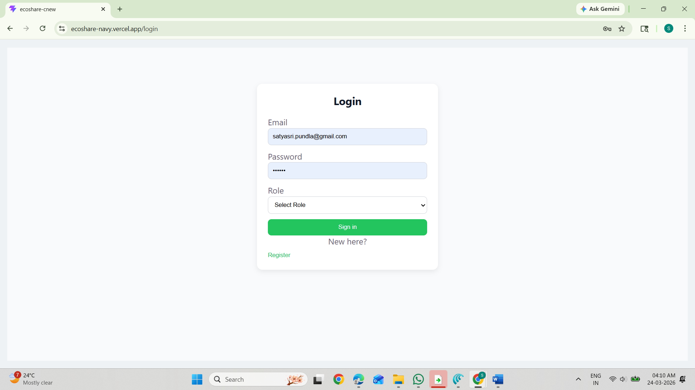

DonationCreation:Donors create a donation by entering details such as donation type quantity, and location. The donation is stored in the database and becomes visible to NGOs.
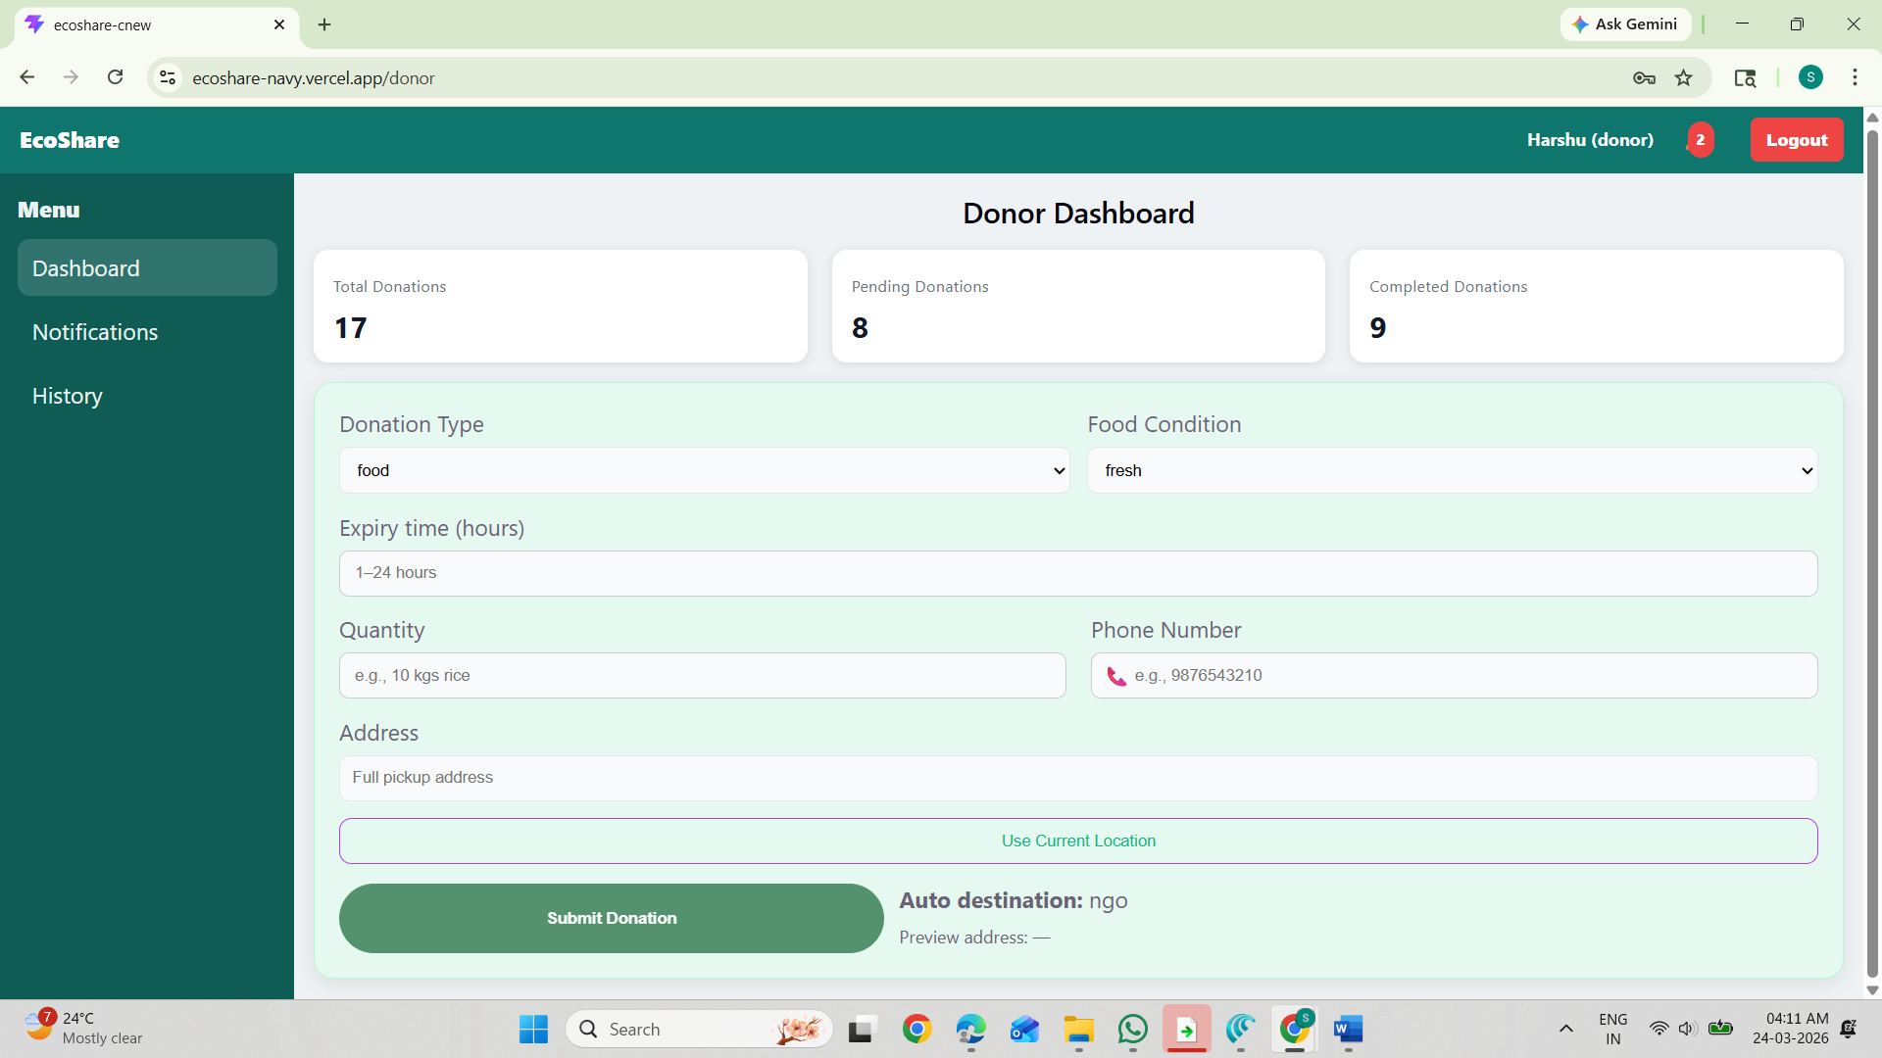
.Donation Availability to NGOs & Compost :can view all available donations on their dashboard and select donations based on their availability.
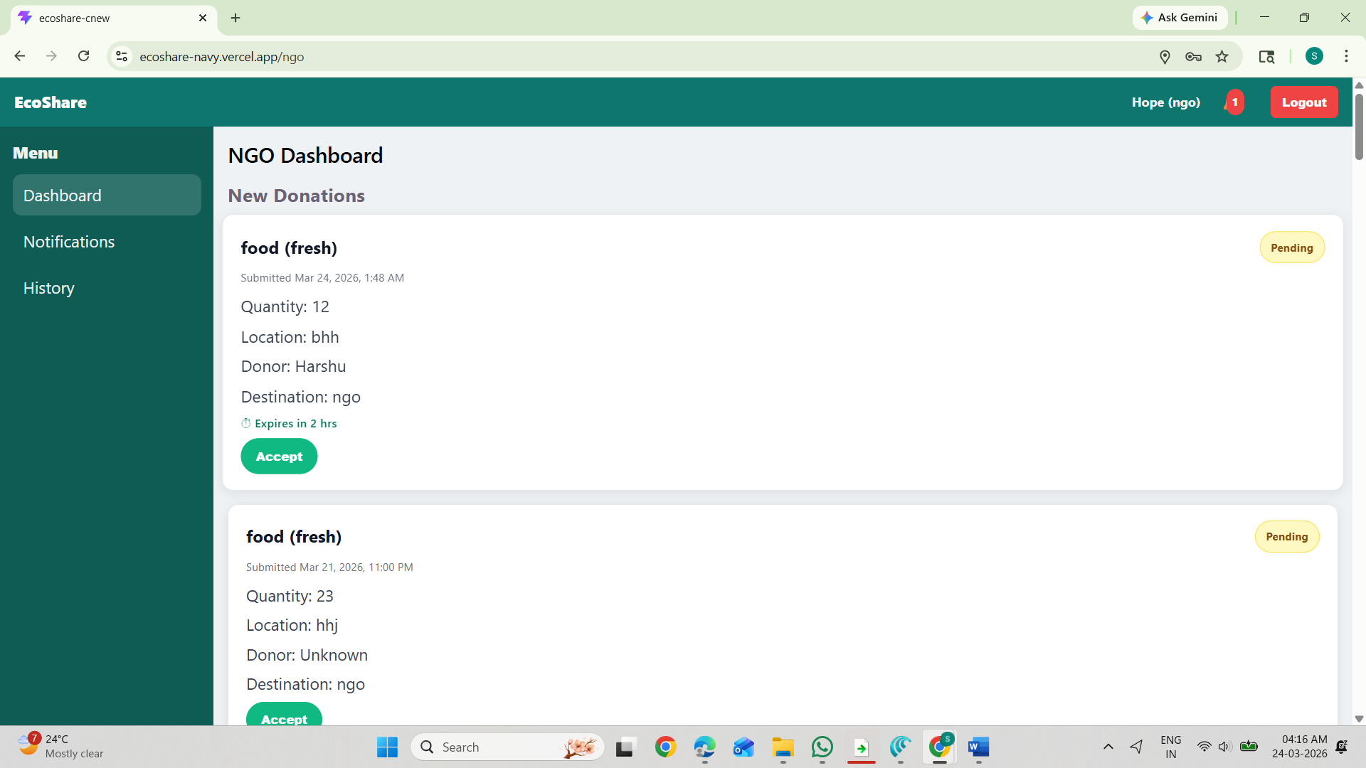
NGO Accepts Donation:NGOs accept a donation and start the collection process. The system updates the donation status to “Accepted”.
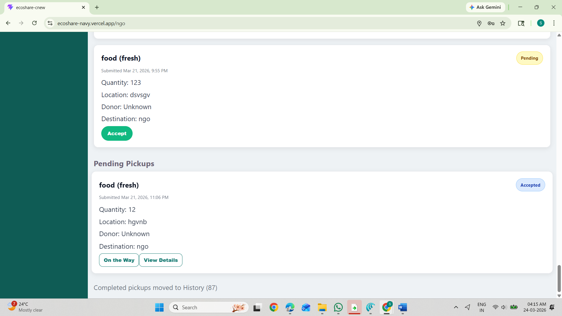

After that when Ngo or Compost is getting started they need to click on the way so donor gets updated location through geofencing notifications
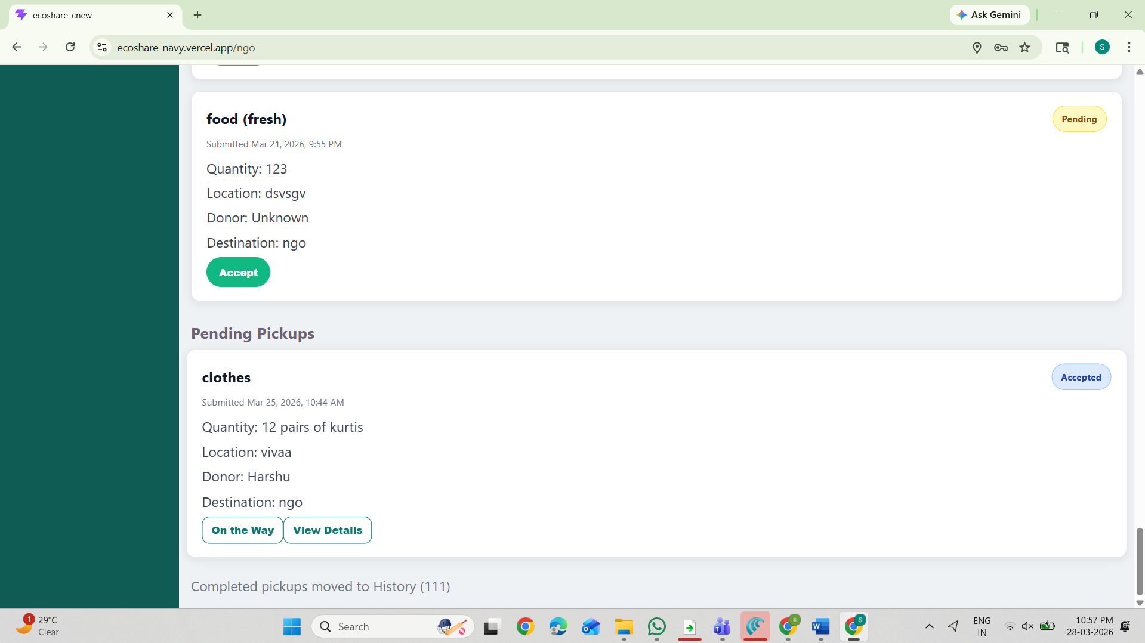
Ngo or Compost can view the details and location of the donor by clicking the view details
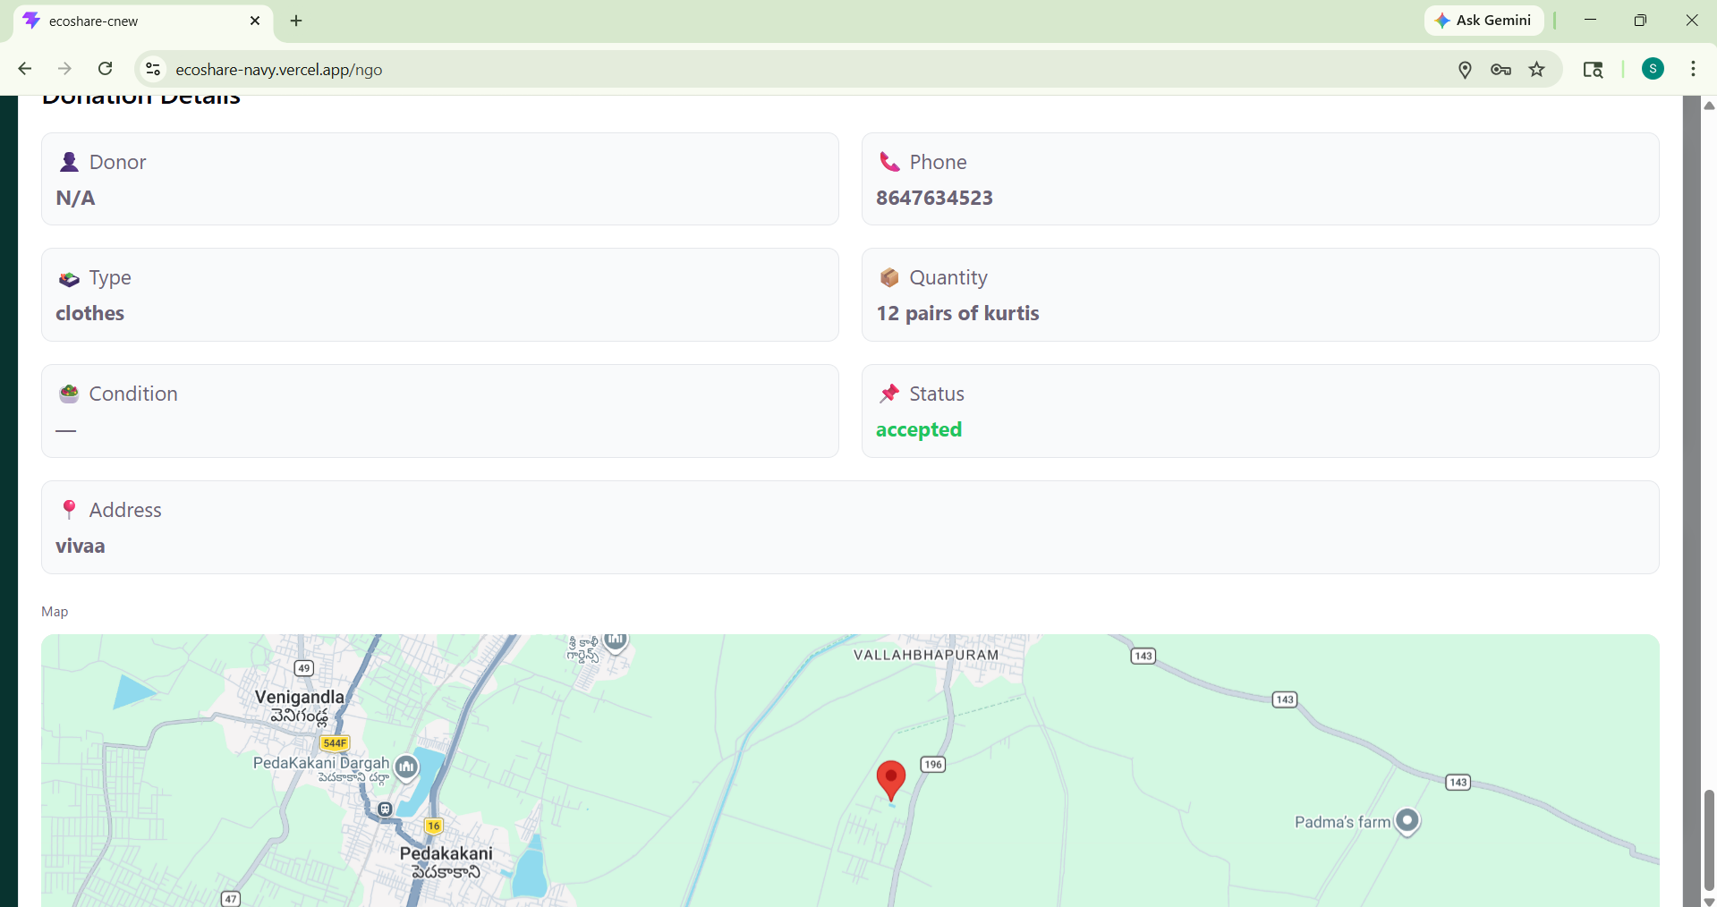

Delivery and Completion:After successful pickup, the NGO marks the donation as “Completed”, indicating that the donation has been successfully picked up
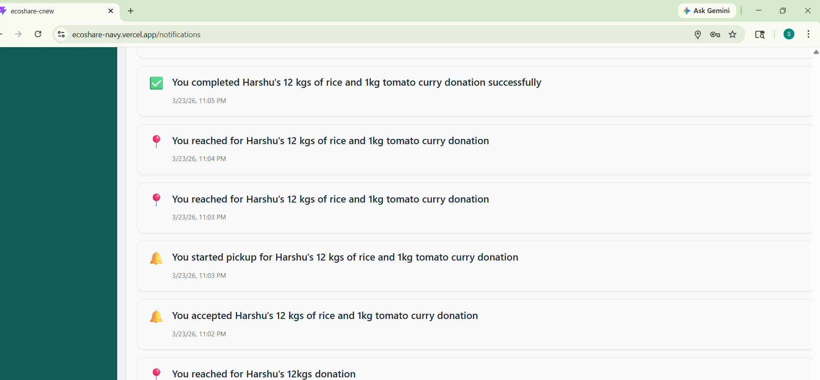

ExpiryHandling (Food Only):If food is not collected within the specified time:
- The system marks it as “Expired”
- It is redirected to Compost Centers for eco-friendly disposal
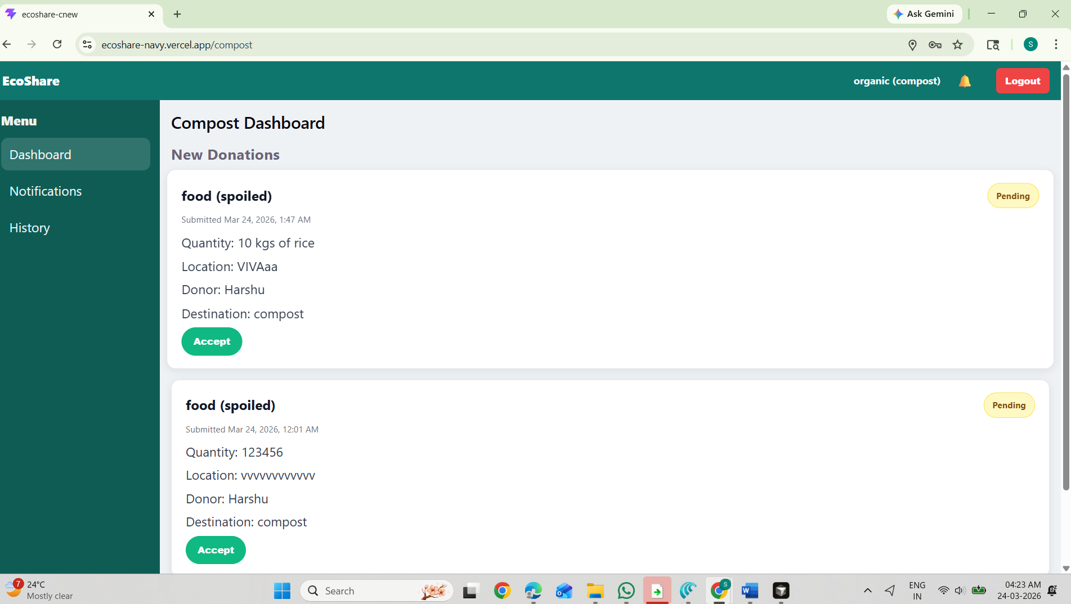

Status Tracking:Donors can track status:
- Accepted → on the way→Reached→ Completed
Notifications are sent at each stage.
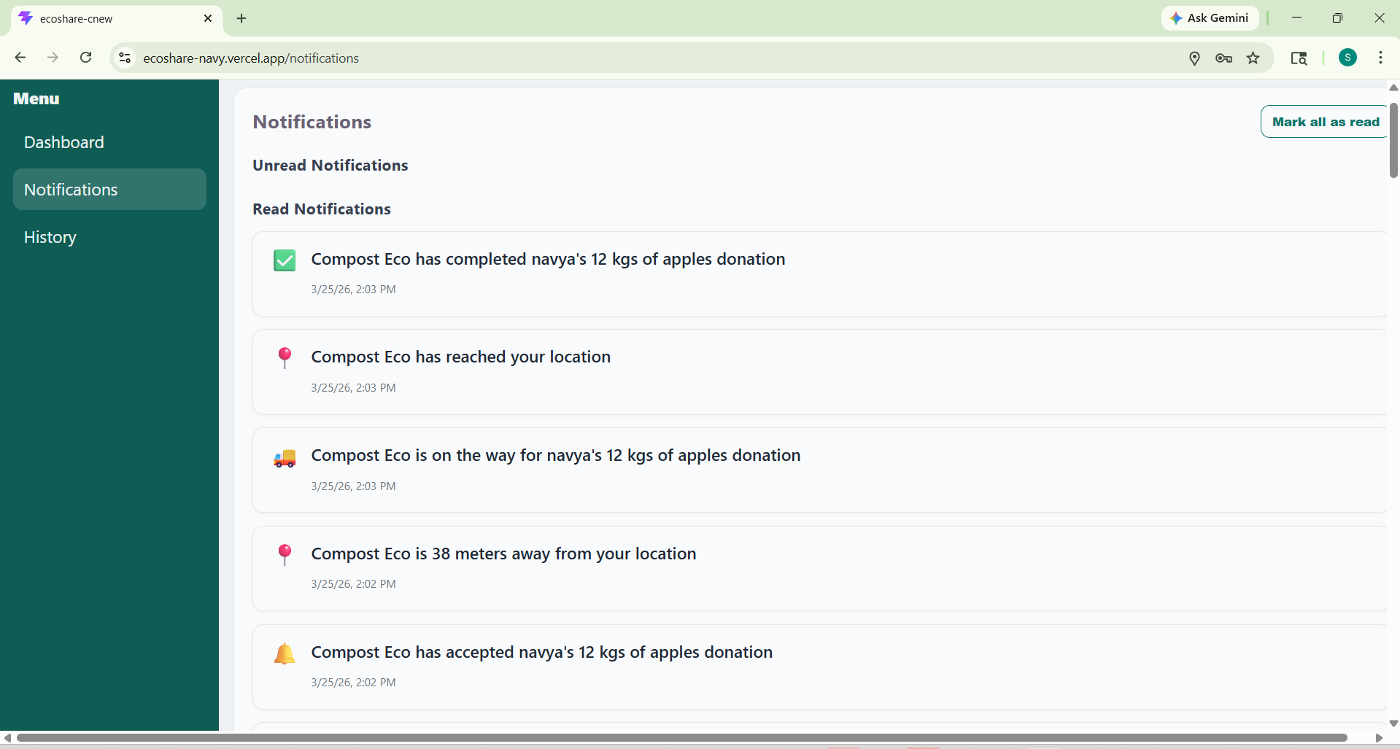

CHAPTER-5

CONCLUSION AND FUTURE SCOPE

CONCLUSION:

This project successfully demonstrates the application of modern web technologies for the efficient management of food and clothes donations through a centralized platform. By integrating a structured workflow involving donors, NGOs, and compost centers, the system ensures proper utilization of surplus resources while minimizing wastage.
The use of technologies such as React for frontend development and Firebase for authentication and database management enables secure, scalable, and efficient system operation. The implementation of role-based dashboards allows users to perform their respective functions effectively, including donation creation, acceptance, processing, and waste handling. The system ensures smooth coordination between stakeholders, improving transparency and reducing manual effort in the donation process.
The inclusion of features such as status tracking and notification updates enhances user experience by providing real-time information about donation activities. The system also incorporates an eco-friendly approach by redirecting expired food to compost centers, promoting environmental sustainability alongside social welfare.
The EcoShare platform provides a reliable solution for managing donations, reducing food and clothing wastage, and supporting underprivileged communities. It simplifies the donation process and ensures that resources are distributed efficiently and responsibly.
Overall, this project highlights the potential of technology in addressing real-world problems related to resource wastage and community support. The system improves coordination, reduces inefficiencies, and contributes to building a more sustainable and socially responsible society.

FUTURE SCOPE:

The future scope of the EcoShare – Smart Food & Clothes Donation System focuses on enhancing the platform by improving efficiency, accessibility, and sustainability through advanced features and technologies.
1. Real-Time Tracking Integration
The system can be enhanced by adding real-time tracking of NGOs during donation collection. This improves transparency and allows donors to monitor the status of their donations more effectively.
2. Mobile and Accessibility Enhancements
A dedicated mobile application can be developed to allow users to create, track, and manage donations easily from smartphones. Additionally, multi-language support can be introduced to improve accessibility for users from different regions.
3. Smart Donation Matching and Recommendations
Intelligent algorithms can be implemented to match donations with nearby NGOs based on location, availability, and donation type. This improves efficiency and reduces delays in donation handling.
4. Advanced Notification System
The system can be enhanced with real-time alerts and reminders for donation activities such as creation, acceptance, progress, completion, and expiry. This improves communication between donors, NGOs, and compost centers.
5. Analytics and Reporting Dashboard
Future improvements can include analytics dashboards that provide insights such as donation statistics, usage trends, and system performance. These reports help in better decision-making and system optimization.
6. Environmental and Sustainability Features
The system can be extended to track the amount of food converted into compost, providing measurable environmental impact. Additionally, clothes recycling and sorting features can be introduced to ensure better utilization of donated clothing.

REFERENCES

Technical Stack & Tool References
•React.js: Documentation for building responsive and interactive user interfaces.
•Firebase Authentication: Used for secure user login, registration, and session management.
•Firebase Firestore: Documentation for real-time cloud database and data storage.
•MongoDB: Used for scalable data management and backend data handling.
•JavaScript, HTML, CSS: Core web technologies for frontend development.
•Security Standards: Input validation and secure authentication practices for data protection.
External API & Service References
•Firebae Services:Used for authentication, real-time database (Firestore), and managing user and donation data efficiently.
•Vercel Deployment Platform:Used for hosting and deploying the web application with fast and reliable performance.
•Notification System:Used for sending updates related to donation activities such as creation, acceptance, completion, and expiry.

APPENDIX :
Appendix A: User Manual
A.1 Donor Operations
• Registration & Login: Users create an account using email and password with Firebase Authentication.
• Donation Creation: Donors enter details such as donation type (food/clothes), quantity, and location.
• Status Tracking: Donors can view the status of donations (Pending, Accepted, In Progress, Completed, Expired).

A.2 NGO Operations
•View Donations: NGOs can view all available donations in the system.
•Accept Donation: NGOs accept donations based on availability.
• Processing: NGOs update donation status during collection and distribution.

A.3 Compost Center Operations
• View Expired Donations: Compost centers receive expired food donation details.
- Accept Donation : Composts accept donations based on availability
- Processing: Composts update donation status during collection and distribution.

Test Case ID | Feature Under Test | Input/Action | Expected Result
TC-01 | User Authentication | Valid Email and Password | User logs in successfully
TC-02 | Donation Creation | Food Donation Entry | Donation stored successfully.
TC-03 | NGO Acceptance | NGO clicks Accept | Status changes to "Accepted"
TC-04 | Status Update | NGO updates status | Status becomes "In Progress/Completed"
TC-05 | Expiry Handling | Food not collected | Status becomes "Expired" and sent to compost

Appendix C: Non-Functional Requirements (NFR)
•Performance: Fast response for donation creation and updates.
•Scalability: Supports multiple users and donations simultaneously.
•Security: Firebase Authentication ensures secure login and data protection.
• Reliability: System maintains consistent performance with minimal errors.

Appendix D: Bibliography & Data Sources
•Technical Stack: React.js, Firebase, MongoDB documentation.
•Infrastructure: Firebase services and Vercel deployment platform.

